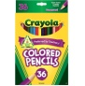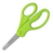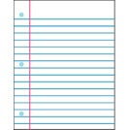**3 Smith-Third Grade Supply List**

Welcome to third grade! To help you take advantage of the “Back to School” sales, here is a list of things your child will need for third grade. Please label as many things as you can along with your child’s backpack and lunchbox. Please send all supplies in on the first day of school.

3 packs of #2 pencils (sharpened if possible – you won’t need a hand held pencil sharpener in class) **Ticonderoga** pencils are the best. They are a little more expensive, but worth it!

Pink erasers

Scissors

1 glue stick (no Elmer’s or liquid glue is needed)

1 black and white style composition notebook

1 package of **wide rule**, loose leaf notebook paper

1 small (1 inch) binder (no trapper keepers or large binders- the new desks are **too small**)

4 pocket folders (1 red, 1 blue, 1 green, 1 purple)

4 Expo dry erase markers (and **1 clean sock** to be used as an eraser)

1 box of 24 crayons or 12 colored pencils

1 small pencil box or baggie to hold supplies

1 pair of headphones (labeled with child’s name and in a baggy for the computer lab)

1 box of tissues