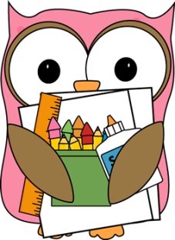**Third Grade Supply List**

**Mrs. Lovett’s Class**

* 5 pocket folders (red, blue, green, purple, and one of your choice)
* Wide ruled paper
* 1 – 1 inch ringed binder
* Pencil box
* 4 – packs of 12 sharpened #2 pencils
* 1 - box of 24 crayons
* 1 - box of colored pencils
* Pencil sharpener
* 2 - pink erasers
* 2 - glue sticks
* 1 - highlighter
* 2 - dry erase markers (eraser on cap if possible)
* Scissors
* 2 - boxes of Kleenex
* Headphones for computer lab (in a labeled Ziploc bag)

**\*\*Optional (but very helpful)\*\***

* 1 package of wet wipes
* Box of snack size, sandwich size, or gallon size Ziploc bags
* Box of plastic spoons