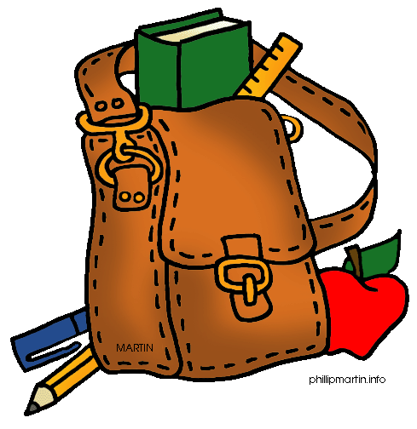

Welcome to 5th Grade!

We hope you have a wonderful summer and we look forward to meeting you in September!

**Here is a list of supplies that you will need in school:**

* **1** two-pocket folder with clasps
* **2** 1-inch binders with clear plastic covers (one red and one blue)
* **2** marble composition notebooks(two different colors)
* **6** tab dividers with pockets
* **1** pkg. of wide ruled loose-leaf paper (200 sheets)
* **1** pkg. of loose-leaf hole reinforcements
* **4** fine point dry erase markers
* **1** pkg.index cards (3 x 5 ruled, 100 ct.)
* at least **2 dozen** sharpened pencils
* **2** large erasers
* **1** hand-held pencil sharpener
* **2** zipper binder supply pouches for in-school supplies
* **1** pair of scissors
* **2** small glue sticks
* **1** box of colored pencils
* **2** boxes of tissues
* 2 sets of ear bud headphones
* **1** box 1-gallon Ziploc bags
* Agendas and Communication Folders will be provided to each student free of charge

It is imperative that students have all of the above items in order to create two complete binders at the beginning of the school year; one for ELA/Reading (blue) and one for Math/Content (red).

Sincerely,

The Fifth Grade Team