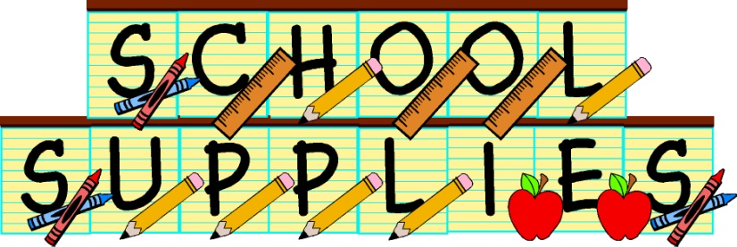

Second Grade

**Mrs. Cousineau’s Class**

* 36 pencils, sharpened ☺- (Ticonderoga brand lasts the longest!)
* 4 large glue sticks
* 1 marble composition notebook*
* 1 box of 24 ct. Crayola crayons*
* 1 box of colored pencils*
* 1 box of tissues
* 1 pair of Fiskar student scissors*
* 1 pack of Expo dry erase markers-(skinny black ones)
* 4 large pink erasers
* Last name A-L: Clorox disinfecting wipes

Last name M-Z: Gallon storage bags

* 2 solid color pocket folders- yellow and blue*
* 1 set of headphones for computer lab* (no earbuds)
* 1 old t-shirt or smock for Art Class*

*I put a star next to the items that need to be labeled with your child’s name. Please DO NOT LABEL THE OTHER ITEMS . THEY WILL BE SHARED BY THE CLASS. Your child does not need a pencil box. I have a class set that fit in desks.

***Crayola products work the best. They go on sale often and tend to hold up and last longer. ☺



Dear Second Grade Families,

Welcome to Second Grade at Wood Road Elementary School. My name is Mrs. Cousineau and I will be your child’s teacher next year. Second grade is a great year, filled with wonderful activities and experiences. We will have fun with science experiments and math investigations; we’ll make new friends, write stories and do research, read fantastic books, and learn how to be an independent learner!

I’d like to take this opportunity to tell you a bit about myself. I have been teaching in the Ballston Spa School District for 18 years. In those years, I’ve taught first, second, and third grades! I feel that my experience teaching the curriculum in the grades before and after second grade gives me an opportunity to know where students are coming from and what they will be expected to know for third grade. Second grade is a great year of learning and discovery, both academically and socially. Learning is a team effort, and you and I have a common goal…to help your child become independent, curious, positive, and hard working. This school year will be a busy year full of opportunities and activities to enrich your child’s learning.

On the back of this page you will find our second grade supply list. I look forward to meet you all. Have a great summer and see you in September!

Sincerely,

Mrs. Cousineau