Accessing Think Central Math Resources
Enter the following website into the address bar:
http://www-k6.thinkcentral.com/ePC/start.do
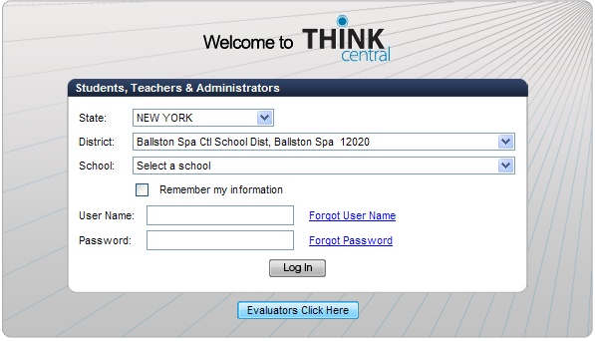
Click on the triangles at the end of each line, and then select the information shown in the picture from the drop-down menu

Enter the following information: (For MTS, MTN, & WR students)
Username: first name and first 3 letters of last name (no spaces) ex: John Smith = johnsmi
***For Malta students:
Username: last name and first 2 letters of first name
Ex. John Smith=smithjo
Password: Student ID number
Click “Log In”

Once you are logged in, click on “My Library”
Click on the first “Go Math: Student Edition” (when it opens up, make sure the front cover has a black box that says “Core Curriculum”).
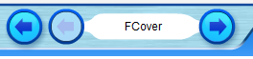
Click on the white box next to the blue arrow at the bottom of the page, enter the number of the page you want to go to, then hit enter.
Use the arrows to navigate through the book.
Go back to last page you were on
Go back
(one page)
Go forward
(one page)
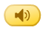
Once on the correct page, you can click on the pictures of the speakers to have the page read to you.
Read or listen to the directions, complete the activities as instructed, and answer the questions that are on the page.

Additional Resources:
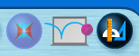
Click on each of the following to:
Access “ iTools.” These are interactive digital manipulatives that can be used to model and explore lesson math concepts.
Access “Destination Math”. Interactive tutorials that teach reinforce new concepts and assign students “missions” in which they will practice their new skills.
Access “Animated Math Models.” Carmen San Diego characters introduce lesson activities with audio and animation. Concepts are modeled and reinforced with feedback.

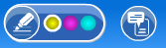

Access an interactive highlighter that can be used to highlight within the book.
Take notes within the book on interactive sticky-notes. You can click on the note, then begin typing text.
Change the highlighter color (the color circled in white is the current color).

