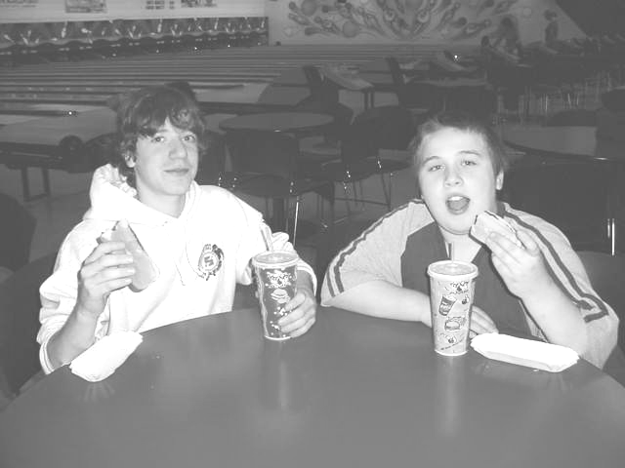
Q: What is Best Buddies?
A: Best Buddies is a non-profit organization established in 1989 by Anthony Kennedy Shriver. The mission of Best Buddies is to establish a global volunteer movement that creates opportunities for one-to-one friendships, integrated employment and leadership development for people with intellectual and developmental disabilities. In middle schools, Best Buddies operates as a student-run friendship club, which creates buddy pairs between students with and without disabilities.
Matt and James, a buddy pair at Magothy River Middle, enjoy snacks during a Best Buddies bowling outing.

Q: If my son/daughter joins Best Buddies, what does that mean?
A: By joining Best Buddies, your son or daughter will become part of a growing movement of people with and without disabilities, dedicated to ensuring everyone has the opportunity to have a friend. He/she will be invited to group activities planned by students and the faculty advisor. At least four group activities are held each year both in school and outside of school. Some examples are pizza parties, bowling outings, kickball games, and ice cream socials. Most importantly, your son/daughter will be “matched” in a one-to-one friendship with another middle school student.
Encourage your child to expand their circle of friends.
Support their decision to join Best Buddies.

For more information, contact:

Q: What will happen when my son/daughter is “matched” with another student?
A: Your child and his/her Buddy will make a commitment to contact each other once a week by telephone, e-mail, talking in school, and/or exchanging notes. Also, buddy pairs will make plans to get together twice a month. Many buddy pairs enjoy eating lunch together, going to assemblies together, or hanging out after school. The purpose of Best Buddies is to foster natural friendships between two people.

Q: Who provides support for the buddy pairs?
A: Best Buddies program staff, a Faculty Advisor, and a Special Education Advisor work together to provide the support and information needed to facilitate strong and lasting relationships.

Q: Does it cost anything to join Best Buddies?
A: There is no fee to join Best Buddies. Best Buddies is a non-profit organization that receives funding through grants, donations, and fundraisers. Group activities are possible through club fundraisers. However, just like any other friendship, if the buddy pairs decide to get together outside of school, each student is responsible for his/her own spending money and transportation.

Q: How does my son/daughter join Best Buddies?
A: It’s simple! Just help your child complete the Membership Application. Visit bestbuddiesonline.org for the application. Once the application signed by you and given to the Best Buddies staff at your child’s school, we will work to match your child with an age appropriate buddy.

Q: What can I do to help?
A: The best way to help is to support your son/daughter in the formation of his/her new friendship. Talk with your child about his/her new friend and ask questions. Encourage him/her to continue the friendship and assist with making arrangements for the buddy pair to spend time together outside of school. If you are willing to volunteer your time to make Best Buddies a success, contact the Best Buddies advisors at school.

